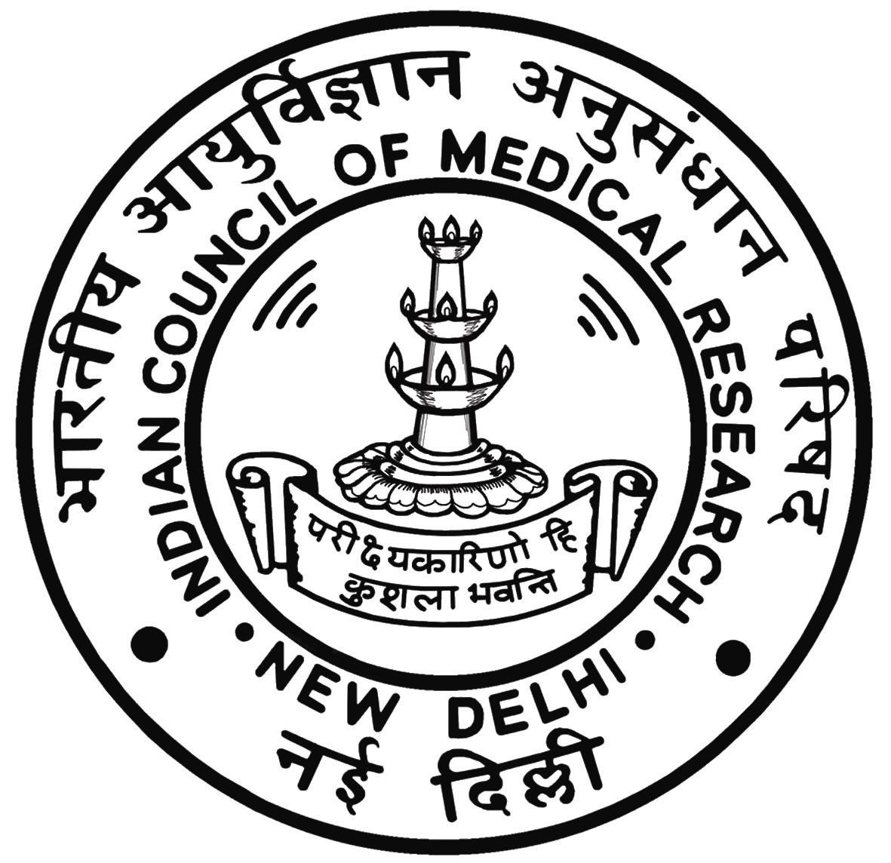
NATIONAL INSTITUTE OF NUTRITION

Latest photo to be affixed and attested by Gazetted Officer
(INDIAN COUNCIL OF MEDICAL RESEARCH)
JAMAI OSMANIA PO, HYDERABAD – 500 007.

&
Dr. NTR UNIVERSITY OF HEALTH SCIENCES, A.P
VIJAYAWADA-520 008

APPLICATION FOR ENTRANCE TEST-CUM-ADMISSION INTO
M.Sc., (APPLIED NUTRITION) COURSE FOR THE YEAR 2015-16

Please read the prospectus carefully before filling up this form

LAST DATE TO SUBMIT THE FILLED IN APPLICATION FORM 30.06.2015
Regn.No. H.T.No.

( For Office Use only)

Are you applying UNDER: Central Quota State Quota
(indicate your answer by using ‘ √ ‘ mark)

- Name of the Candidates ( IN BLOCK LETTERS as in Degree Certificate)

- Name of the Father/Husband/Guardian

- Nationality and State of Domicile :
(Copy of domicile certificate to be enclosed by
candidates applying under CENTRAL QUOTA)

- Address
P.O
PIN

E-mail

Phone | STD  Code - | Tel. No.
Mobile

Date Month Year

- a) Date of Birth:

b) Age (as on 31.12.2014): Years Months Days

6. Sex: Male Female
(indicate your answer by using ‘ √ ‘ mark)

7. a) Social Status (State Quota) (indicate your answer by using ‘ √ ‘ mark)

OC | BC |  |  |  |  | SC | ST
OC | A | B | C | D | E | SC | ST

b) Social Status (Central Quota) (indicate your answer by using ‘ √ ‘ mark)

OC | OBC | SC | ST

8. Educational Qualification (indicate your answer by using ‘ √ ‘ mark, strike off whichever is not applicable):

a) MBBS b) B.Sc., (Nutrition/Home Science/Nursing)

c) B.Sc., (Biochemistry/Nutrition as a major subject)

Qualifying Degree | Institution with Address | Month & Year of passing and  Name of the University | % of marks in the qualifying examination (upto 2 decimal places)

b) Marks obtained in the qualifying examination (Year wise)

Year | Subject | Maximum Marks | Marks Obtained
I.

II.

III.

IV.

Any Other
 | Total

9. a) Particulars of Education for 7 years study up to qualifying examination (bonafide study certificate to be enclosed)

Class/Course | Year |  | Name & Place with District and State of Institution
Class/Course | From | To | Name & Place with District and State of Institution
IX Class
X Class
1st Intermediate
2nd Intermediate
Degree

b) Local / Non-Local area to which the candidate belongs:
AU | OU | SVU | Non-Local
(only for candidates applying under State Quota)
(indicate your answer by using ‘ √ ‘ mark)

Yes No
10) Are you claiming seat under Central Quota (indicate your answer using ‘ √ ‘ mark)

If yes, mention the state the candidate belongs to :
(enclose relevant certificate)
11. Details of the Registration Fee of Rs. 3000/- (for OC/OBC/BC) & Rs. 2700/- (for SC/ST).

DD No. | Date | Name of the Bank/Branch

Note: DD to be drawn in favour of the Director, National Institute of Nutrition, payable at Hyderabad

12. Any other information the candidate desires to furnish

DECLARATION

I, Sri / Smt. / Kum. ________________________________________hereby solemnly and sincerely affirm that the statements made and information furnished in the application form and also in all other enclosures thereto submitted by me/him/her are true. Should it however be found that any information furnished therein is untrue in material particulars, I realise that I am liable to criminal prosecution and also agree to forego my seat / that he/she should forego his seat in the college.

Signature of Parent/Guardian Signature of the Candidate

DOCUMENTS TO BE ENCLOSED ALONG WITH APPLICATION FORM

- Original DD for Rs. 3000/- (for OC/OBC/BC) & Rs. 2700/- (for SC/ST) towards Application fee.
- Clearly visible Photostat copies of all marks statements from 1st to Final year of qualifying exam attested by Gazetted Officer.
- Attested copy of the Internship Certificate mentioning date of commencement and completion of Internship wherever applicable.
- Attested copy of Provisional or Original Degree Certificate of qualifying exam.
- Attested copy of Study Certificates from 9th to qualifying examination.
- If the applicant has not studied qualifying examination in Telangana/Andhra Pradesh, he/she shall submit following certificates as per regulation 5.2 to 5.6 whichever is applicable to the applicant.(Refer Prospectus)
(a) 10 Years Residence Certificate of the candidate in the State of T.S/A.P. (OR)
(b) 10 Years Residence Certificate of either of the Parents/Spouse (Certificate of relationship also shall be enclosed)
- Copy of Social Status (caste) Certificate attested by Gazetted Officer.
- Candidates in State Quota claiming eligibility as Local / Non-Local should furnish relevant certificates in support of their claim.
- Candidates who have studied in the state of Telangana/Andhra Pradesh.
- if the candidate has studied in any educational institution, study/ bonafide certificate from IX Class to Degree (Govt. ZPH/Private School or College) shall be submitted.
- A candidate who has studied in 2 or more institutions in various place in Telangana/Andhra Pradesh, study bonafide certificate from IX Class to Degree (Govt/ZPH/Private School or College) in those places shall be submitted.
- A candidate who has not studied a class in any school / institution, a residence certificate for that period only shall be submitted.
- Candidate who have not studied in any school/ college in the state of T.S/A.P., but resided in Andhra Pradesh with private study in Telangana/Andhra Pradesh seven years residence certificate mentioning the period of residence preceding the qualifying examination (IX to Degree) by the candidate claiming eligibility as a local by virtue of residence shall be submitted.
10. Candidates who have studied in the institutions outside the State of Telangana/Andhra Pradesh have to submit 10 years residence certificate of the either of the parents issued by MRO to claim seats under non-local category of State Quota.

Note: 1. Applications submitted without the above required documents shall stand rejected automatically.
2. All the originals should be produced at the time of counseling for selection.
HALL TICKET

ORIGINAL

NATIONAL INSTITUTE OF NUTRITION
Indian Council of Medical Research
Jamai-Osmania PO, Hyderabad-500 007, India

& Reg.No.

Dr.NTR University of Health Sciences
Vijayawada, Andhra Pradesh
FOR OFFICE USE ONLY

MASTER OF SCIENCE (APPLIED NUTRITION) COURSE (2015-2016)

Time and Date : 11.00 am to 12.30 pm on 02-08-2015 Hall Ticket No.
Test Centre : Dr.NTR University of Health Sciences, Vijayawada

(To be filled in by the candidate in his / her own handwriting and to be submitted along with the application)

Latest passport size photograph to be affixed duly attested by Gazetted officer
1. Name of the Candidate : ___________________________________________
(in Block Letters)

2. Name of the Father/ Husband: ___________________________________________

3. Identification Marks a) ___________________________________________
b) ____________________________________________

Signature of the Hall ticket Issuing Authority Signature of the Candidate

NOTE:
- The Hall Ticket shall be preserved and shall be presented to the supervising officer at the Entrance Test Centre and at the time of selection.
- The Candidate without the valid Hall Ticket shall not be allowed to sit for the Entrance Test.
- This Hall Ticket shall be preserved till the admission to the M.Sc. (Applied Nutrition) is over.
- No traveling expenses will be paid for journey for appearing for Entrance Test or for selections.
- Violation of any instruction and adoption of any malpractices in the examination hall, or otherwise shall render the registration of candidate liable for cancellation as well as his/her script and forfeiture of his/her claim for appearing in the Entrance Test. The decision of the Chief Superintendent of the Entrance Test Centre shall be final in all those matters.

INSTRUCTIONS TO THE CANDIDATE

- Candidates must be present in the entrance test hall 30 minutes before the commencement of the test.
- The candidates are required to bring BALL POINT (BLUE OR BLACK) for marking answers in the answer sheet separately provided for Test.
- They should not write their name or initials or address anywhere on the answer sheet or question paper.
- Strict silence should be maintained in the examination hall.
- Candidates shall not be admitted into the examination hall after 10.45 am
- Hall Ticket No. to be written only in the box provided in the question paper and answer sheet writing one digit in each box, and darken the numbers corresponding to the Hall Ticket as indicated below:

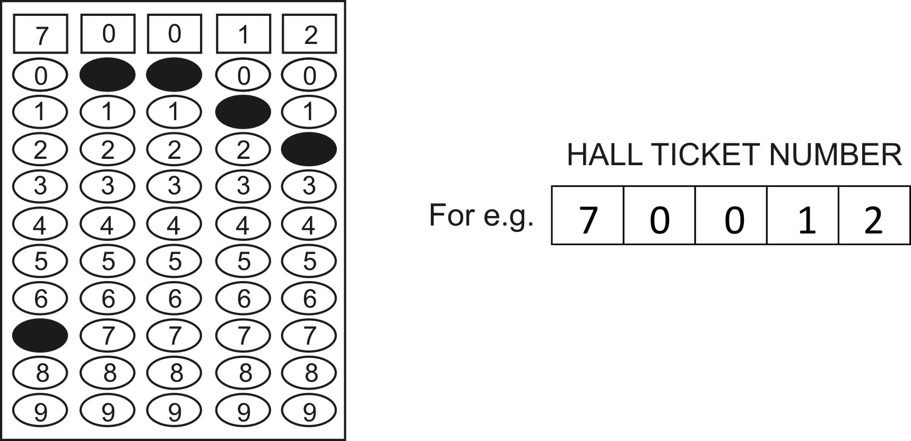

NB: Failure to write Hall Ticket No. will result in rejection of the answer script

- No candidate is allowed to carry with him to the examination hall any written, printed or blank paper (except the Hall Ticket), calculator, computer or any other Electronic Gadget including pager & cellular phone.
- The answer script will be separate from the question paper and the candidate is expected to mark his/her response correctly as shown below:

- The boxes showing the question booklet number and question booklet code in the OMR answer sheet need not be filled.
- Answer will not be valued if the candidate marks more than one response for the same question or answering after erasing the marking.
- On completion of answering the questions, he / she should seek the permission of the invigilator and leave the hall only after handing over the question paper and answer script to the invigilator.
- Any candidate resorting to any malpractice in the examination will have his / her examination invalidated and will be liable to be debarred from appearing for the test permanently.

HALL TICKET

DUPLICATE
NATIONAL INSTITUTE OF NUTRITION
Indian Council of Medical Research
Jamai-Osmania PO, Hyderabad-500 007, India

& Reg.No.

Dr.NTR University of Health Sciences
Vijayawada, Andhra Pradesh
FOR OFFICE USE ONLY

MASTER OF SCIENCE (APPLIED NUTRITION) COURSE (2015-2016)

Time and Date : 11.00 am to 12.30 pm. on 02-08-2015 Hall Ticket No.
Test Centre : Dr.NTR University of Health Sciences, Vijayawada

(To be filled in by the candidate in his / her own handwriting and to be submitted along with the application)

Latest passport size photograph to be affixed duly attested by Gazetted Officer
1. Name of the Candidate : ___________________________________________
(in Block Letters)

2. Name of the Father/ Husband: ___________________________________________

3. Identification Marks a) ___________________________________________
b) ____________________________________________

Signature of the Hall ticket Issuing Authority Signature of the Candidate

NOTE:
- The Hall Ticket shall be preserved and shall be presented to the supervising officer at the Entrance Test Centre and at the time of selection.
- The Candidate without the valid Hall Ticket shall not be allowed to sit for the Entrance Test.
- This Hall Ticket shall be preserved till the admission to the M.Sc. (Applied Nutrition) is over.
- No traveling expenses will be paid for journey for appearing for Entrance Test or for selections.
- Violation of any instruction and adoption of any malpractices in the examination hall, or otherwise shall render the registration of candidate liable for cancellation as well as his/her script and forfeiture of his/her claim for appearing in the Entrance Test. The decision of the Chief Superintendent of the Entrance Test Centre shall be final in all those matters.

INSTRUCTIONS TO THE CANDIDATE

- Candidates must be present in the entrance test hall 30 minutes before the commencement of the test.
- The candidates are required to bring BALL POINT (BLUE OR BLACK) for marking answers in the answer sheet separately provided for Test.
- They should not write their name or initials or address anywhere on the answer sheet or question paper.
- Strict silence should be maintained in the examination hall.
- Candidates shall not be admitted into the examination hall after 10.45 am.
- Hall Ticket No. to be written only in the box provided in the question paper and answer sheet writing one digit in each box, and darken the numbers corresponding to the Hall Ticket as indicated below:

NB: Failure to write Hall Ticket No. will result in rejection of the answer script

- No candidate is allowed to carry with him to the examination hall any written, printed or blank paper (except the Hall Ticket), calculator, computer or any other Electronic Gadget including pager & cellular phone.
- The answer script will be separate from the question paper and the candidate is expected to mark his/her response correctly as shown below:

- The boxes showing the question booklet number and question booklet code in the OMR answer sheet need not be filled.
- Answer will not be valued if the candidate marks more than one response for the same question or answering after erasing the marking.
- On completion of answering the questions, he / she should seek the permission of the invigilator and leave the hall only after handing over the question paper and answer script to the invigilator.
- Any candidate resorting to any malpractice in the examination will have his / her examination invalidated and will be liable to be debarred from appearing for the test permanently.

HALL TICKET

TRIPLICATE
NATIONAL INSTITUTE OF NUTRITION
Indian Council of Medical Research
Jamai-Osmania PO, Hyderabad-500 007, India

& Reg.No.

Dr.NTR University of Health Sciences
Vijayawada, Andhra Pradesh
FOR OFFICE USE ONLY

MASTER OF SCIENCE (APPLIED NUTRITION) COURSE (2015-2016)

Time and Date : 11.00 am to 12.30 pm. on 02-08-2015 Hall Ticket No.
Test Centre : Dr.NTR University of Health Sciences, Vijayawada

(To be filled in by the candidate in his / her own handwriting and to be submitted along with the application)

Latest passport size photograph to be affixed duly attested by Gazetted Officer
1. Name of the Candidate : ___________________________________________
(in Block Letters)

2. Name of the Father/ Husband: ___________________________________________

3. Identification Marks a) ___________________________________________
b) ____________________________________________

Signature of the Hall ticket Issuing Authority Signature of the Candidate

NOTE:
- The Hall Ticket shall be preserved and shall be presented to the supervising officer at the Entrance Test Centre and at the time of selection.
- The Candidate without the valid Hall Ticket shall not be allowed to sit for the Entrance Test.
- This Hall Ticket shall be preserved till the admission to the M.Sc. (Applied Nutrition) is over.
- No traveling expenses will be paid for journey for appearing for Entrance Test or for selections.
- Violation of any instruction and adoption of any malpractices in the examination hall, or otherwise shall render the registration of candidate liable for cancellation as well as his/her script and forfeiture of his/her claim for appearing in the Entrance Test. The decision of the Chief Superintendent of the Entrance Test Centre shall be final in all those matters.

INSTRUCTIONS TO THE CANDIDATE

- Candidates must be present in the entrance test hall 30 minutes before the commencement of the test.
- The candidates are required to bring BALL POINT (BLUE OR BLACK) for marking answers in the answer sheet separately provided for Test.
- They should not write their name or initials or address anywhere on the answer sheet or question paper.
- Strict silence should be maintained in the examination hall.
- Candidates shall not be admitted into the examination hall after 10.45 am.
- Hall Ticket No. to be written only in the box provided in the question paper and answer sheet writing one digit in each box, and darken the numbers corresponding to the Hall Ticket as indicated below:

NB: Failure to write Hall Ticket No. will result in rejection of the answer script

- No candidate is allowed to carry with him to the examination hall any written, printed or blank paper (except the Hall Ticket), calculator, computer or any other Electronic Gadget including pager & cellular phone.
- The answer script will be separate from the question paper and the candidate is expected to mark his/her response correctly as shown below:

- The boxes showing the question booklet number and question booklet code in the OMR answer sheet need not be filled.
- Answer will not be valued if the candidate marks more than one response for the same question or answering after erasing the marking.
- On completion of answering the questions, he / she should seek the permission of the invigilator and leave the hall only after handing over the question paper and answer script to the invigilator.
- Any candidate resorting to any malpractice in the examination will have his / her examination invalidated and will be liable to be debarred from appearing for the test permanently.

